APPLICATION DEVELOPMENT AND EMERGING TECHNOLOGIES COMPREHENSIVE REPORT

Prepared For:
Johneros Puyo

Prepared By:
Jenefer Z. Ignacio

Course and Section:
BSCS - 3A

Date of Submission:
September 12, 2026

Overview
This comprehensive report is prepared by TechVision Consulting Inc., an established firm that supports technology adoption in today's world. As technologies evolve, many companies and organizations struggle to keep up. This report aims to guide clients in their strategic planning and future investments.

1. Introduction
The impact of emerging technologies is becoming increasingly prominent every day. Therefore, understanding their capabilities and strategic applications is essential to incorporate them effectively into competitive, evolving organizations. For this reason, we prepared this report to guide businesses and government leaders to adopt these technologies successfully. This comprehensive report covers the following:
- definition of emerging technologies
- characteristics of emerging technologies
- areas of emerging technologies that have the potential to impact several fields
- application of various emerging technologies in businesses and government

2. Defining Emerging Technologies
The word emerge comes directly from the Latin word “emergere”, which means to “bring forth, come up, or rise”, according to the definition by Etymonline (Harper, n.d). Simply put, emergence is something becoming more prominent or relevant. Today, the most notable emerging technology most people know is Artificial Intelligence, specifically generative AI. We can’t deny that it’s actively changing how we interact with the world, even for ordinary citizens.
Emerging technologies are commonly defined as new technologies, either currently developing or to be developed in the foreseeable future. But most people confuse all new technologies with emerging technologies, which is not the case. To be considered an emerging technology, it must be progressive and have a massive potential impact across different fields and industries.

3. Characteristics of Emerging Technologies
According to Rotolo et al. (2015), there are also other ways to classify an emerging technology. This will help you understand and identify their potential impact. It can be labeled through the following five (5) main characteristics:
- Radical Novelty
Cambridge Dictionary (n.d) defines novelty as “something that has not been experienced before”. In the context of emerging technologies, radical novelty can refer to an entirely new technology or even a repurposed technology. If an existing technology is made to fulfill functions different from its usual use, it may be classified as being radically novel. One example of an existing technology that is put to new use to achieve different results is Artificial Intelligence (Rotolo et al., 2015). Most people do not know that AI is not a newly invented technology. Artificial Intelligence was born at the Dartmouth Summer Research Project in 1956. Today, the most prominent use of Artificial Intelligence is generative AI. It has spread across our digital world, from generative photos to customer-support AI.
- Relatively Fast Growth
We can see a vast difference between emerging and non-emerging technologies in their growth rates. This is evident in the pace of development, funding, and scale. Using generative AI again as an example, specifically ChatGPT, we can observe the overwhelming number of users it has gained over the past months. There is no denying that AI is now taking over various fields and industries, especially with how fast this emerging technology is growing.
- Coherence
Coherence is defined as “the situation when the parts of something fit together naturally or reasonably” by Cambridge Dictionary (n.d). Various technologies come together to form connections that support different uses and outcomes. Technologies that are yet to be developed or are still in the conceptual stage are set apart from these already established technologies, which have been united by their internal characteristics and logical connections. Examples include cloud, artificial intelligence, data analytics, and robotics (Rotolo et al., 2015).

- Prominent Impact
A technology can be identified as an emerging technology if it has a massive impact on our socio-economic system and has significantly transformed different sectors worldwide. These changes are significant enough that people can clearly see them or measure their contribution to the economy. Artificial intelligence is another example; it has changed how we interact with the world. We can see this in how it has changed healthcare, businesses, and even our daily lives.

- Uncertainty and Ambiguity
Uncertainty refers to a technology's potential to have a major impact in the foreseeable future and its unpredictability. Meanwhile, ambiguity lies in its potential to adapt to different uses and applications and its flexibility. For example, generative AI faces uncertainty and ambiguity because it’s unclear how the market will receive it and how it will be adapted across sectors. Even in the future, AI applications are still under development; thus, they still face uncertainty and ambiguity.

4. Emerging Technology Areas
The following are areas of emerging technologies that have the potential to impact several fields, especially businesses and the government:
- Augmented Reality (AR)
It allows digital elements such as sound, text, visuals, and effects to overlap in the real world. People can use it through mobile phones and even glasses. It is one of the technologies that has the most positive impact on the socio-economic system. One notable contribution of augmented reality is its use in emergencies, with AR-assisted simulation maps. Another example is the most famous augmented reality game, Pokémon Go. It is one of the technologies that has the most positive impact on the socio-economic system, and it is rapidly transforming how different sectors visualize data and make strategic decisions.

- Artificial Intelligence (AI)
Artificial Intelligence gives organizations a tool to analyze data and make strategic decisions through learning, reasoning, and self-correction. AI can also learn from experience, like humans, through Machine Learning. For example, in healthcare, AI can identify and develop new medication rapidly, while in finance it serves as a tool for fraud detection. This makes it one of the most adaptable tools for businesses and governments today.

- Quantum Computers
Quantum computers use quantum mechanics to solve problems that regular desktop computers cannot solve as efficiently. Instead of using standard bits, these computers use qubits. This allows them to process information as a 0 and a 1 at the same time. IBM, Google, Rigetti Computing, and IonQ are major players that have successfully built quantum computers. This technology greatly helps researchers and scientists run simulations and experiments. It has a significant impact on science and industry now and in the foreseeable future.

5. Application of Emerging Technologies in Various Industries
The following technologies can be considered as the core pillars of modern technology in the fourth industrial revolution. They continuously transform relationships between organizations, producers, suppliers, and customers. They also change how humans and machines interact. This section will guide businesses and organizations in efficiently implementing and adopting these technologies in their respective industries.
Technology | Description | Key Features | Examples
Big Data Analytics | This technology examines large, complex datasets to discover patterns and trends. It supports real-time decision-making by providing quick, immediate answers through cutting-edge technologies. | Key features include real-time decision-making, customer insights, and pattern discovery. | Netflix Content Recommendations, Fraud Detection, GPS
Internet of Things (IoT) | This technology is found in everyday objects connected to the Internet. These physical objects are embedded with sensors and software that connect and communicate with other devices on the Internet. | Key features include sensors, wireless connectivity, and real-time responses and results. | Smart Lighting, Fitness Trackers, Smart Traffic Lights
Cloud Computing | This technology refers to services delivered over the Internet. This includes servers, storage, and databases. Cloud computing does not rely on local hard drives, thus making data access faster and easier from anywhere. | Key features include remote services, data-driven production, and fast response times. | Google Drive, Mobile Banking, Xbox Cloud Gaming
Augmented Reality (AR) | This technology overlays digital information, such as text, audio, visuals, and effects, on the real world through mobile phones or smart glasses. In the future, AR may be used and developed significantly as a tool for real-time decision-making. | Its key features are real-time information, improved decision-making, and work procedures. | Pokémon Go, Social Media Filters, Google Maps Live View

6. Conclusion
Emerging technologies are not only a major part of our world, but they are also shaping our future. For businesses and governments, understanding these technologies is essential when making strategic decisions and future investments. This comprehensive report explains how Augmented Reality, Artificial Intelligence, and Quantum Computers show clear characteristics such as radical novelty, rapid growth, coherence, and significant impact. Although these technologies still face uncertainty and ambiguity, their potential is undeniable. With Big Data Analytics, the Internet of Things, Cloud Computing, and Augmented Reality as core pillars of modern technology, businesses and governments can make real-time decisions and improve daily operations. To keep up in the modern world, organizations must understand emerging technologies to adopt them efficiently and adapt to their continuous development.

References
Artificial Intelligence (n.d.). In TechTarget. Retrieved from https://searchenterpriseai.techtarget.com/definition/AI-Artificial-Intelligence
Cambridge University Press. (n.d.). Novelty. In Cambridge dictionary. Retrieved September 10, 2026, from https://dictionary.cambridge.org/us/dictionary/english/novelty
Harper, D. (n.d.). Etymology of emergence. Online Etymology Dictionary. Retrieved September 10, 2026, from https://www.etymonline.com/word/emergence
Rotolo, D., Hicks, D., & Martin, B. (2015). What is an emerging technology?. SPRU Working Paper Series, 44, 1-34. doi: 10.6084/M9.FIGSHARE.1335986

AI Checker:
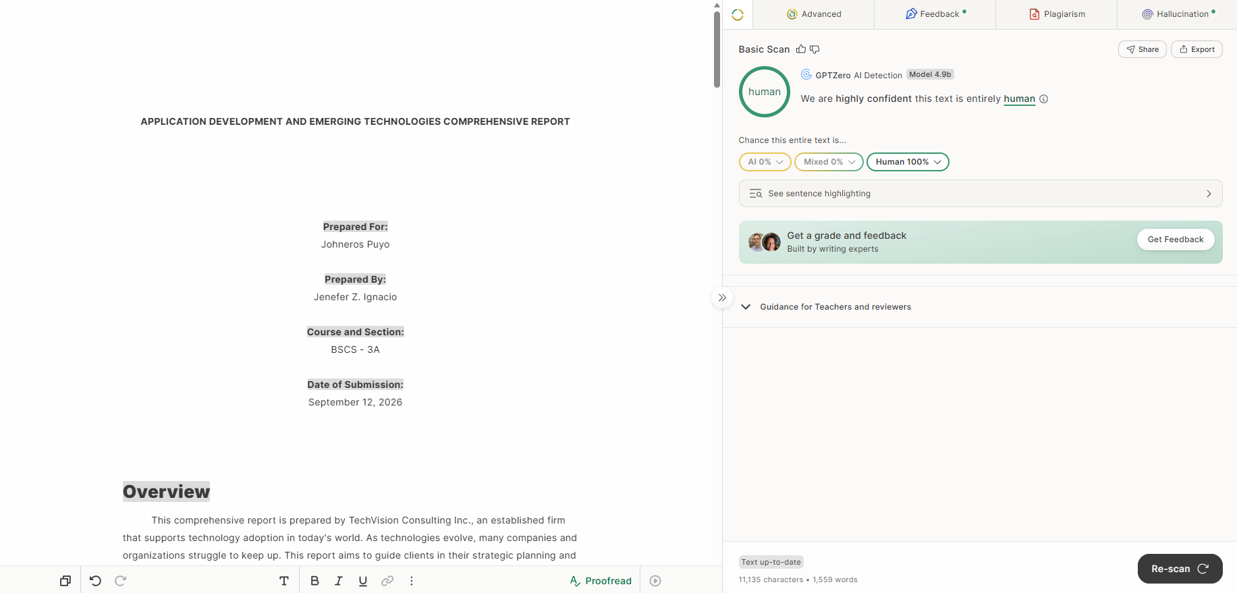

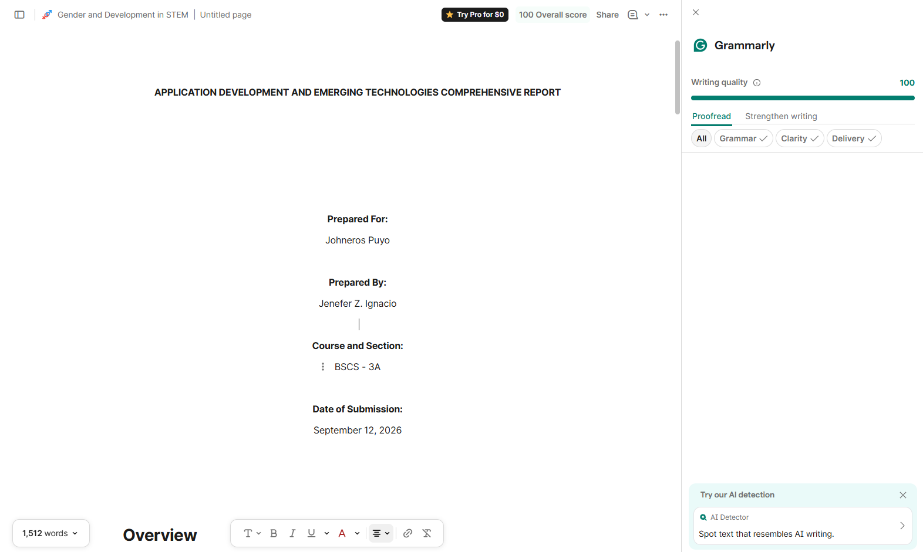
Grammarly:

Rubric:
Criteria | Weight
Accuracy of content (based on lecture) | 25%
Completeness of all sections | 20%
Depth of analysis and explanations | 20%
Use of examples and applications | 15%
Organization and professional format | 10%
Originality (own words, no copying) | 10%
TOTAL : 100%

